GYANMANJARI INNOVATIVE UNIVERSITY
Department of Civil Engineering

Industry Visit Report
2025-26

LOCATION: -Shivomand Vedanta Commercial site, ISCON 11, Near GMIU, Sidsar road, Bhavnagar.

Program: - Diplomain Civil Engg.
Semester: - 1st, 3rd and 5th Semester Diploma and 1st and 3rd Interior Design diploma students.

Date: - 28.07.2025
Conducted by: -Prof.Gaurang M. Chauhan& Prof. Dipika V. Zinzuvadiya
Assistance Professor’s, Civil Engineering Department
Gyanmanjari Innovative University, Bhavnagar.
Mobile No: - 7984631112.
Submitted By: -
Prof. Gaurang Chauhan
TPA Coordinator – Civil Engineering Dept.

INDEX
SR NO | CONTENT | PAGE NO
1 | Acknowledgement | 03
2 | Introduction to Visit Industry | 04
3 | Session wise visit details | 05
4 | Students Attendance | 06
5 | Photographs | 09
6 | Conclusion | 13

ACKNOWLEDGEMENT

We would like to express our sincere gratitude to the management of Gyanmanjari Innovative University for organizing this valuable industrial visit. We are thankful to our respected Principal, Head of Department, and all faculty members for their continuous support.

We would also like to thank the management and staff of Shiv Om and Vedanta commercial site for providing us with this opportunity and for their warm hospitality during the visit. Also, thanks to Prof. Gaurang Chauhan, TPA Coordinator, for coordinating and leading the visit successfully.

INTRODUCTION TO VISITED INDUSTRY

The visit was organized to Shivom & Vedanta commercial site located at ISCON 11, Near GMIU, sidsar road, Bhavnagar. The construction site specializes in their G+7 building site management work.

The purpose of the visit was to provide students with real-time exposure to civil engineering practices and to bridge the gap between academic knowledge and industrial applications.

SESSION-WISE VISIT DETAILS

Time | Activity | Description
10:30 AM TO 10:45AM | Welcome & Orientation | Introduction to the company& site and safety briefing
10:45 AM TO 12:45 PM | Site Tour | Construction works and management system working
12:45 PM TO 01:15 PM | Closing | Group photo and conclusion

ATTENDANCE
- DIPLOMA 1ST INTERIOR DESIGN 1ST AND 3RD
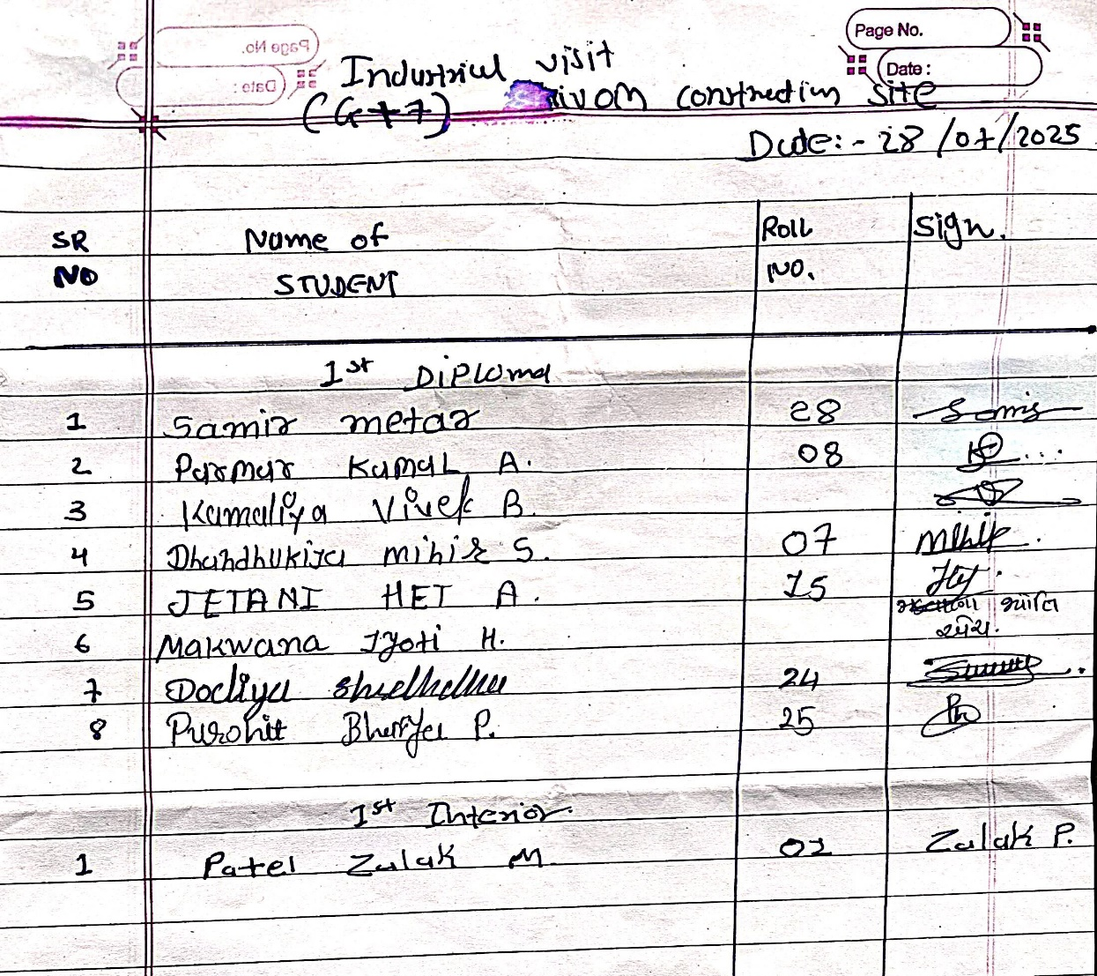

- DIPLOMA 3RD AND 5TH
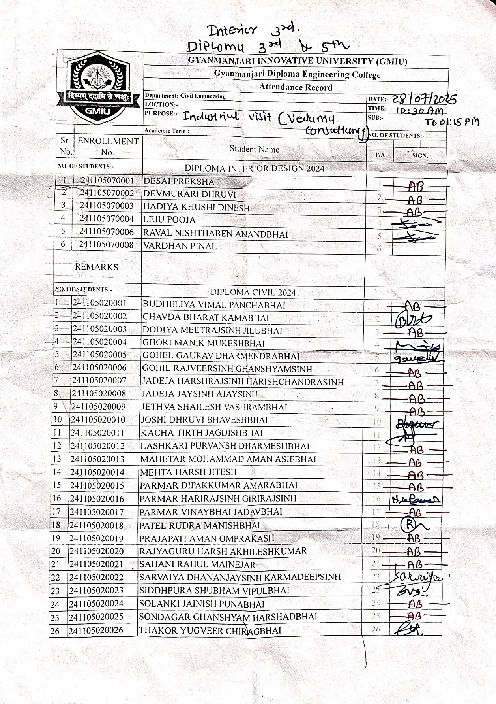
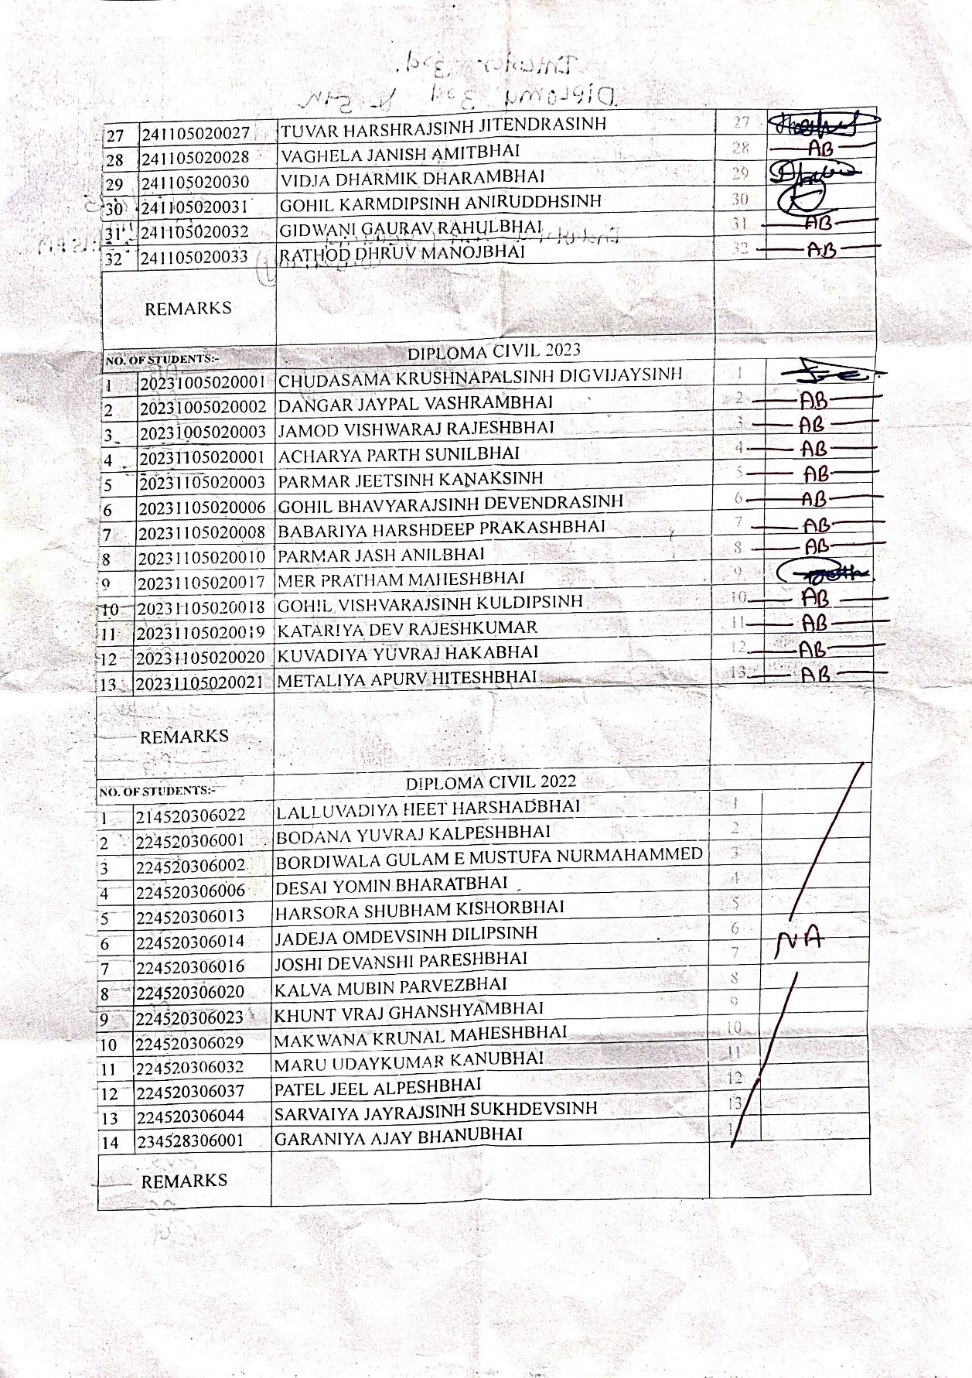

PHOTOGRAPHS
Details | Photos
Students interacting with engineers at ShivOmand Vedanta site | 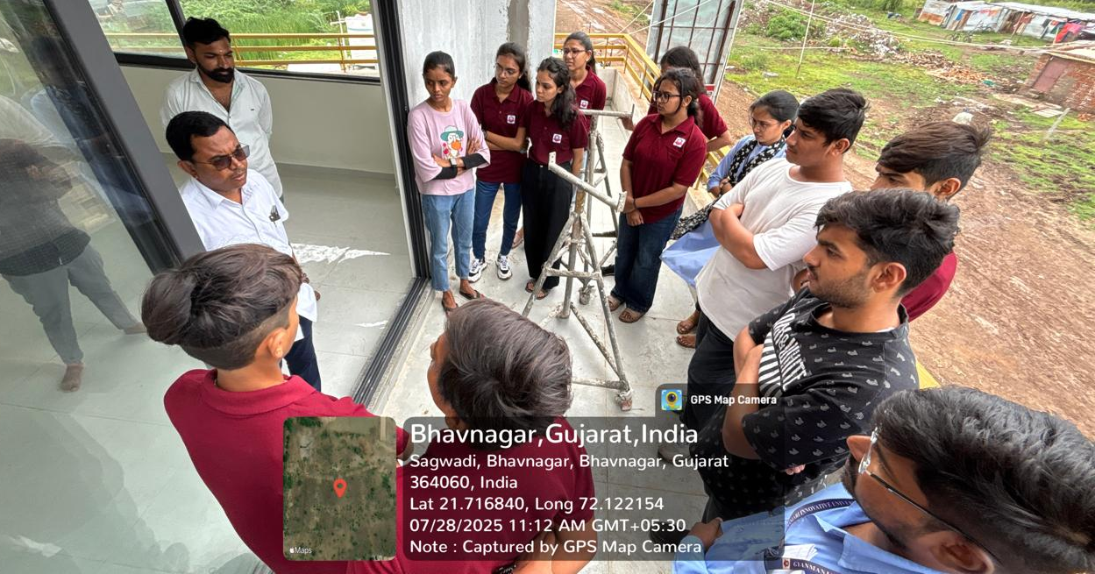  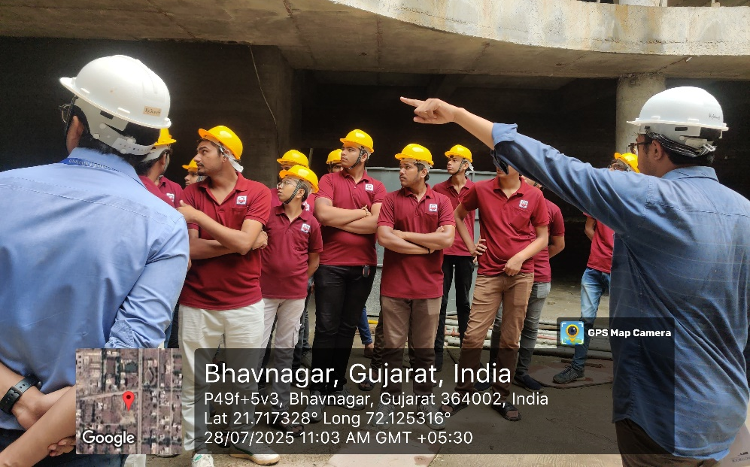  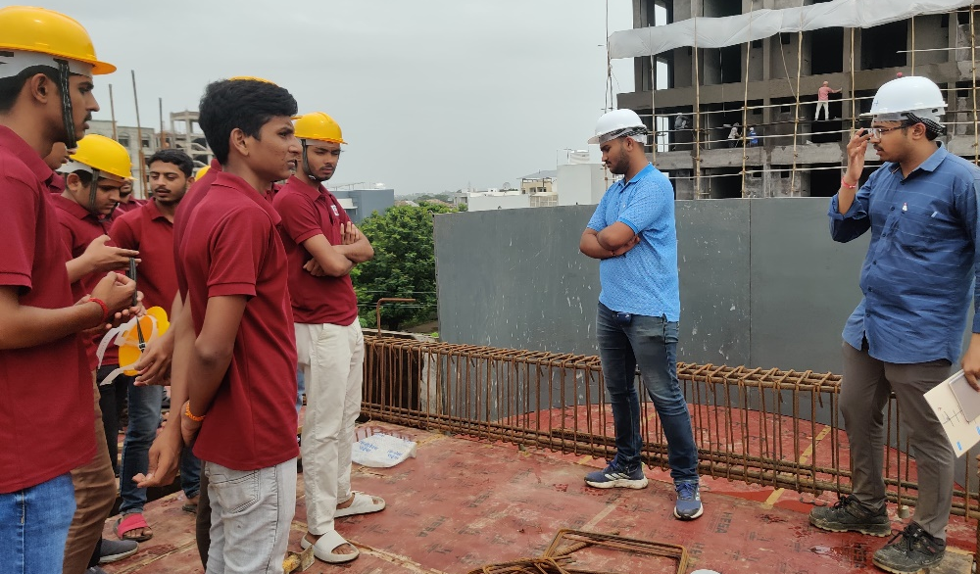
Group photo with industry personnel | 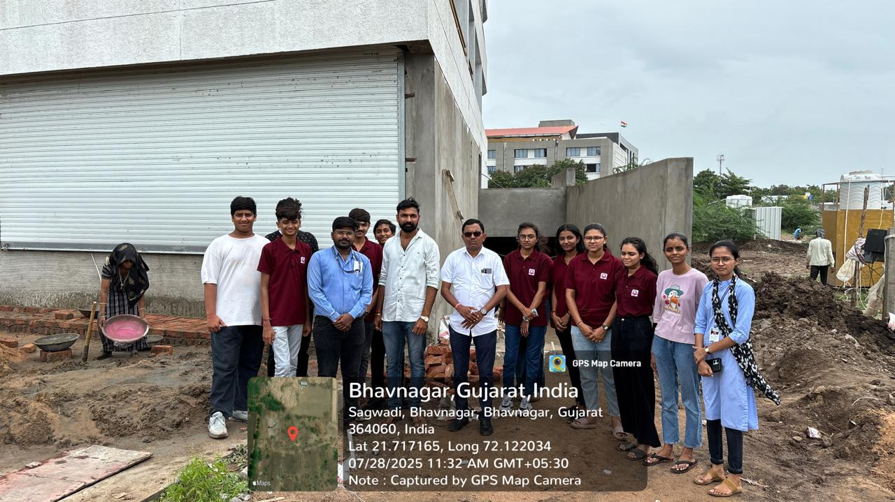  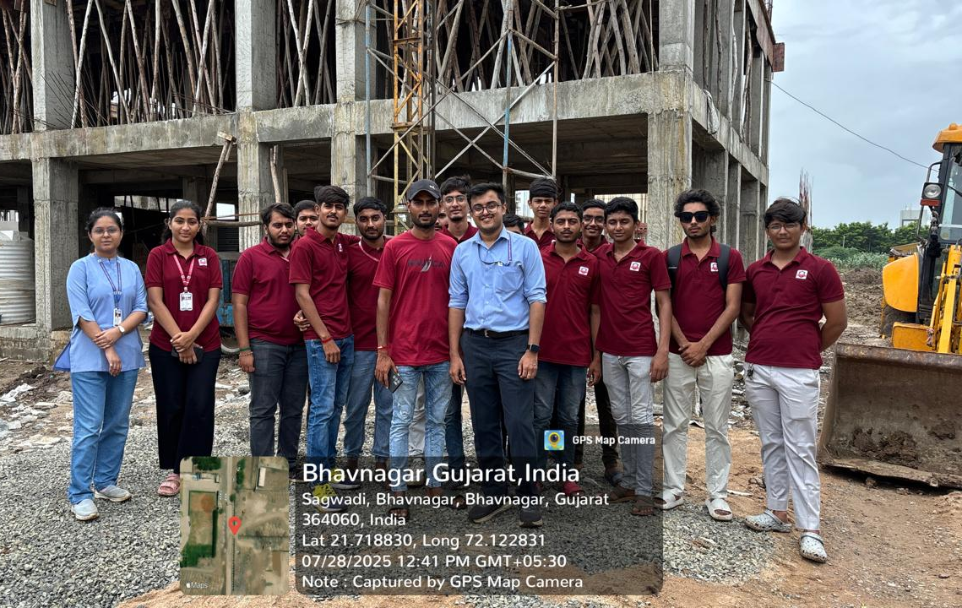
On site process observation | 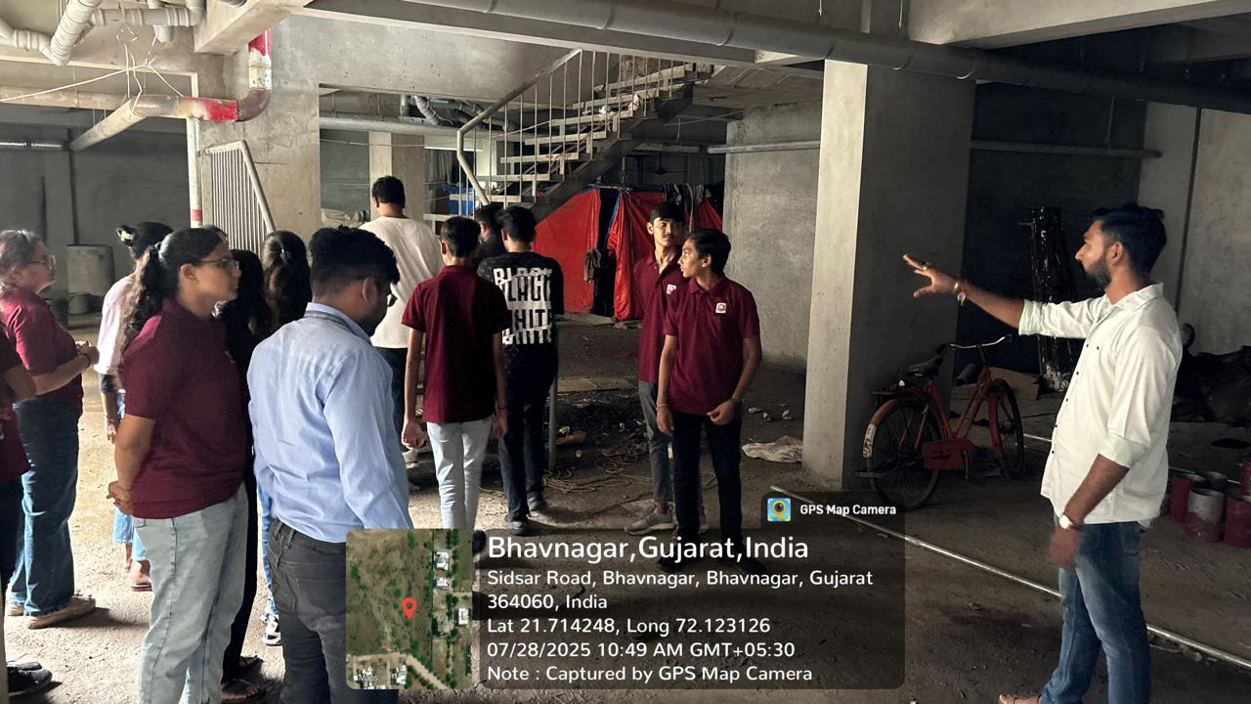  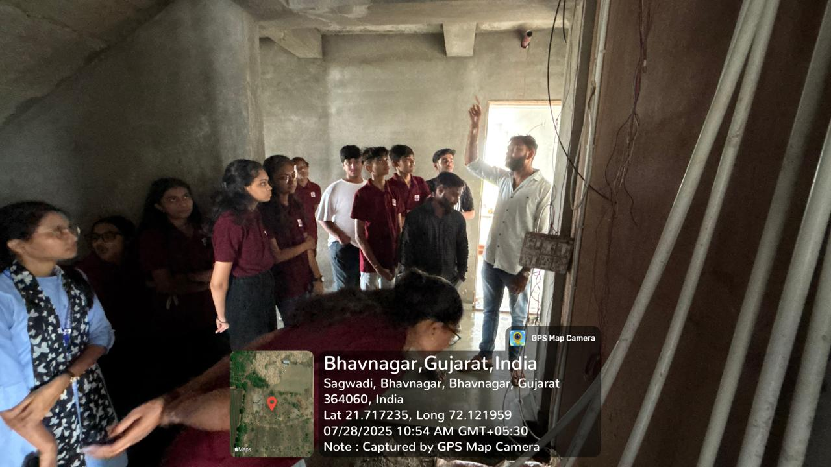  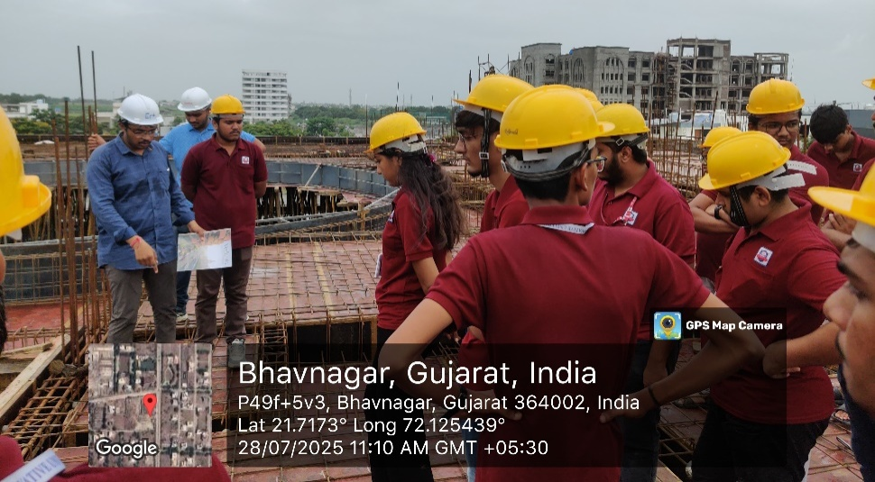
Safety | 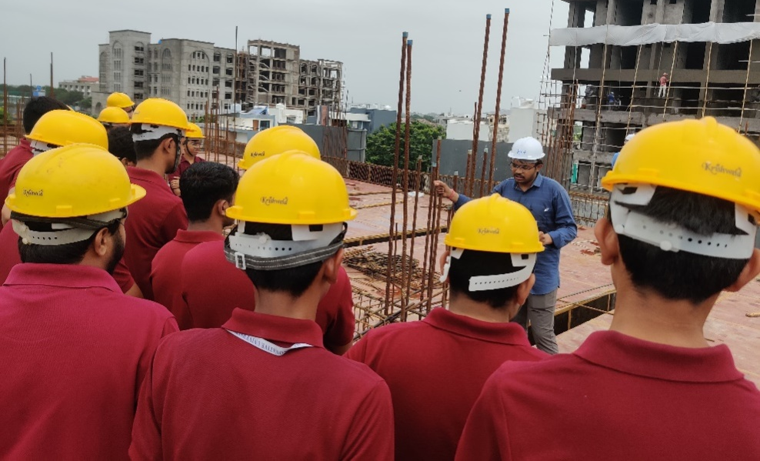

CONCLUSION

The industrial visit to Vedanta commercial site provided valuable insights into practical civil engineering applications. Students were exposed to field operations, quality control practices, and safety protocols.

This visit helped students connect classroom learning with real-world engineering practices and inspired them to gain industry-relevant skills.

Such initiatives are highly beneficial for holistic development and career readiness.

